Chapter 14, Problem 82.

Scale the lowpass active filter in Fig. 14.99 so that its corner frequency increases from 1 rad/s to 200 rad/s. Use a 1-μF capacitor.

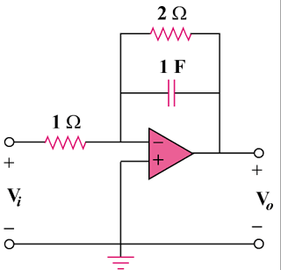

Figure 14.99
For Prob. 14.82.

